**CHAPTER FIVE**

**SYSTEM IMPLEMENTATION**

**5.0 INTRODUCTION**

System implementation and deployment is the part in which the system will be implemented and deployed into real life to be used. The system can only be implemented and deployed when the system design and analysis is completed.

This chapter details out the implementation of the system. This include mapping logical design onto physical platform, the construction which consist of screen shots of forms, databases and reports among others. The chapter will also outline the various testing that were performed on the system, that is unit and system testing and the results obtained.

**5.1 MAPPING LOGICAL DESIGN ONTO PHYSICAL PLATFORM**

Logical design involves arranging data into a series of logical relationships called entities and attributes. Here, we defined the various fields for the database schema. Customer first names, e-mail, shipping address and other details were converted into first_name, email and shipping_address respectively. The Django framework and the other development tools were used to develop the various model of the project and linked them together. The next sub-topic gives a graphical view of the various outputs after transforming the logical design into executable codes.

**5.1.1 HARDWARE REQUIREMENTS**

The minimum hardware requirement in develop this system are listed as below:

|  |  |
| --- | --- |
| Hardware Description | Minimum Requirements |
|  |  |
| Processor | Intel Pentium D 3.4GHz / AMD Athlon II |
|  | X2 250 u (Minimum) |
|  | Intel Core 2 Duo E4400 2.0GHz / AMD |
|  | Athlon 64 X2 Dual Core 4600+ |
|  | (Recommended) |
|  |  |
| Memory | 1 GB RAM Recommended, 256 MB |
|  | RAM (Minimum) |
|  |  |
| Hard disk space | Up to 3 GB Recommended |
|  |  |
| Display | 65536 colors, set to at least 1024 X 768 |
|  | Resolution |

Table 5.0 Table of Hardware Requirements

**5.1.2 SOFTWARE REQUIREMENTS**

The minimum software requirement in develop this system are listed as below:

|  |  |
| --- | --- |
| Software Description | Minimum Requirements |
|  |  |
| Operating System (OS) | All 32-bits Microsoft Windows |
|  | (95/98/2000/XP/7/8) |
|  |  |
| Browser | Mozilla Firefox (15.0 & above), Internet |
|  | Explorer (8.0 & above), Google Chrome |
|  | (20.0 & above). |

Table 5.1 Table of Software Requirements

**5.2 CONSTRUCTION**

This section focuses on the pictorial view of the user interface including the various forms, databases and reports. Below are various screen shots showing how the system was constructed.

The screenshots of the various tables constructed are shown below:

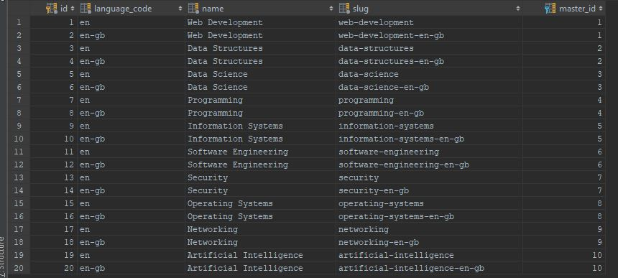

*Fig 5.0 Database Schema for categories table*

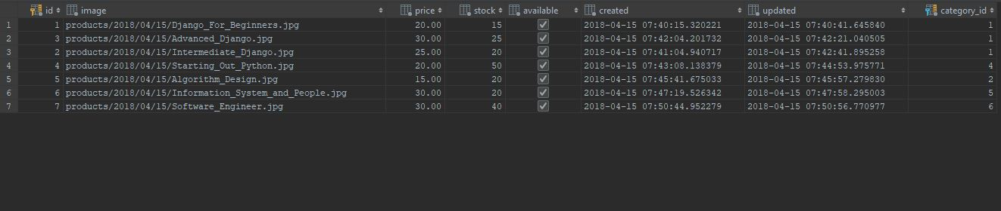

*Fig 5.1 Database Schema for product table*

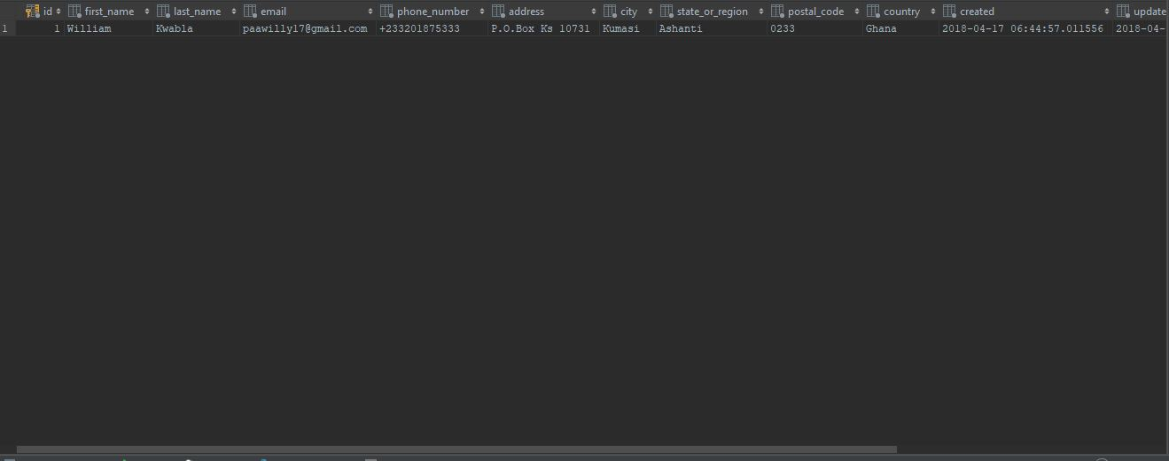

*Fig 5.2 Database Schema for orders table*

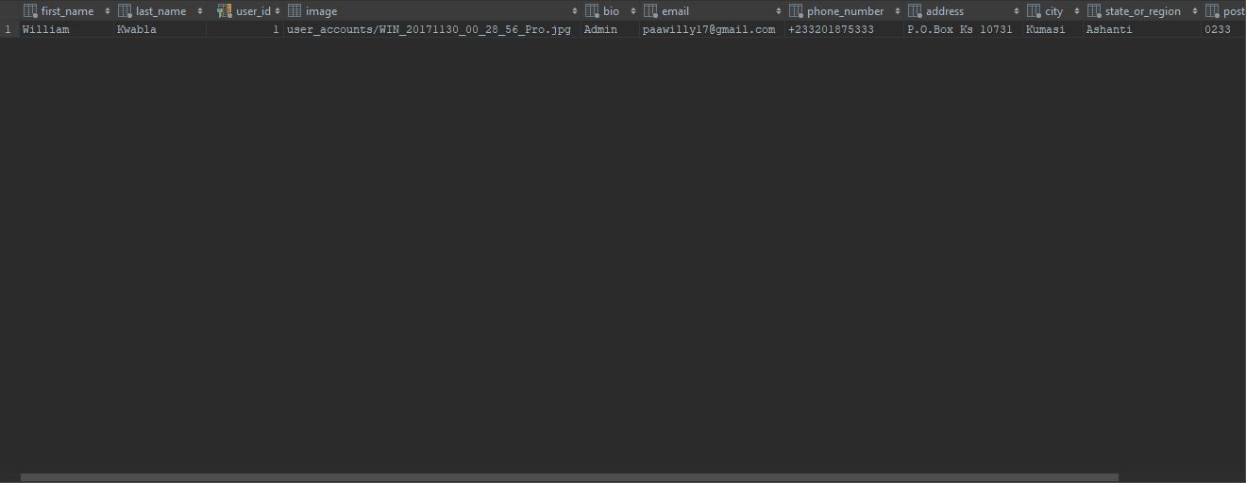

*Fig 5.3 Database Schema for Customer Profiles table*

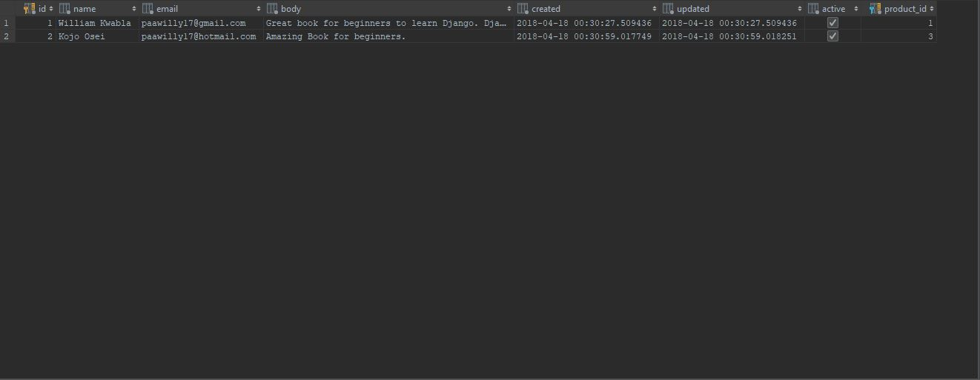

*Fig 5.4 Database Schema for Product Review table*

**5.2.1 USER INTERFACES**

As we mentioned in the previous chapter about how the user interface would be designed, below are the screenshots of the various user interfaces of the system.

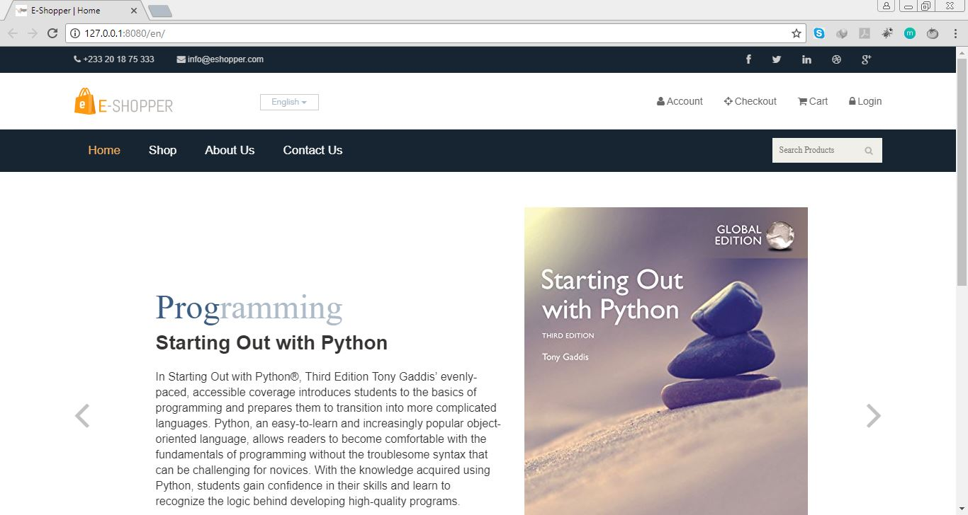

*Fig 5.5 Homepage of the application with a slideshow of some of the books sold.*

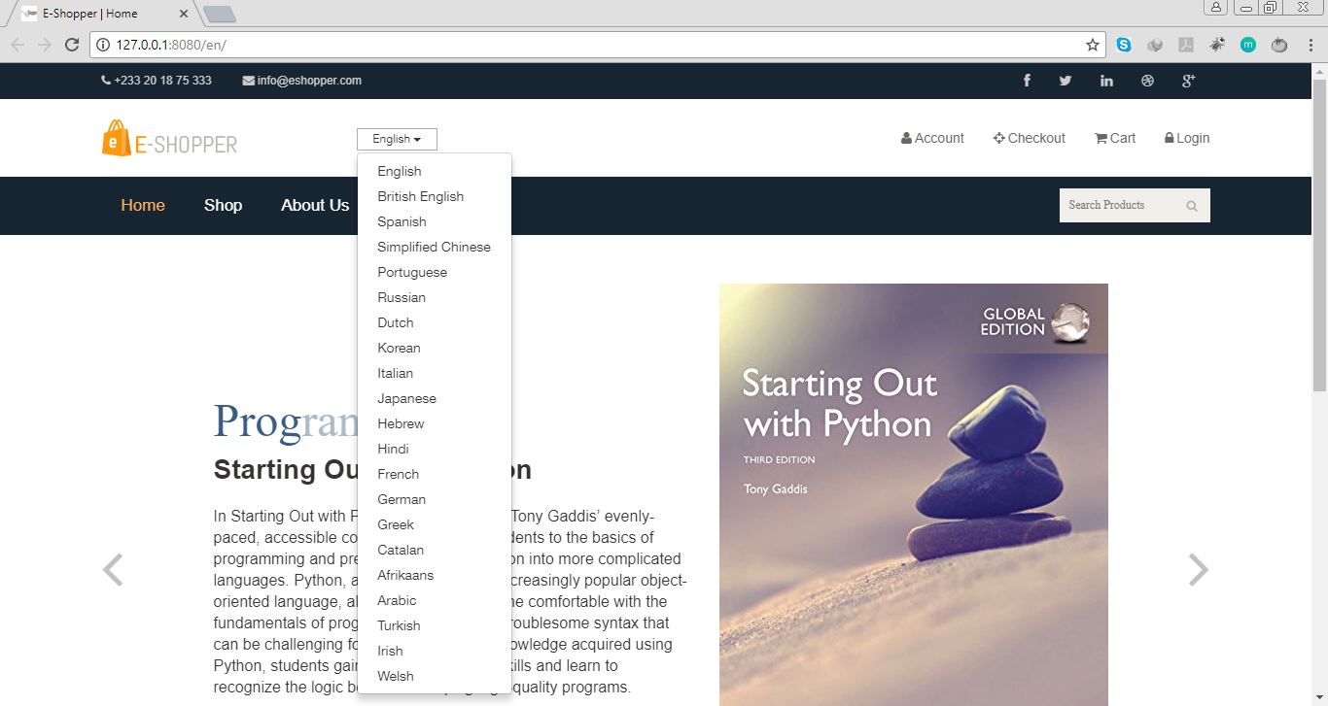

*Fig 5.6 Homepage with a dropdown of 21 languages available for customers to choose before they start shopping.*

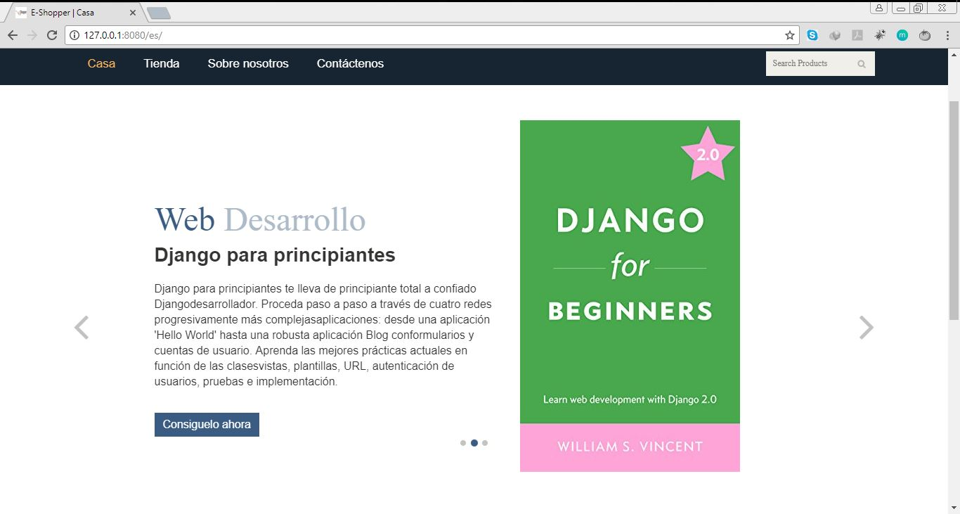

*Fig 5.7 Homepage and URL after Spanish is selected.*

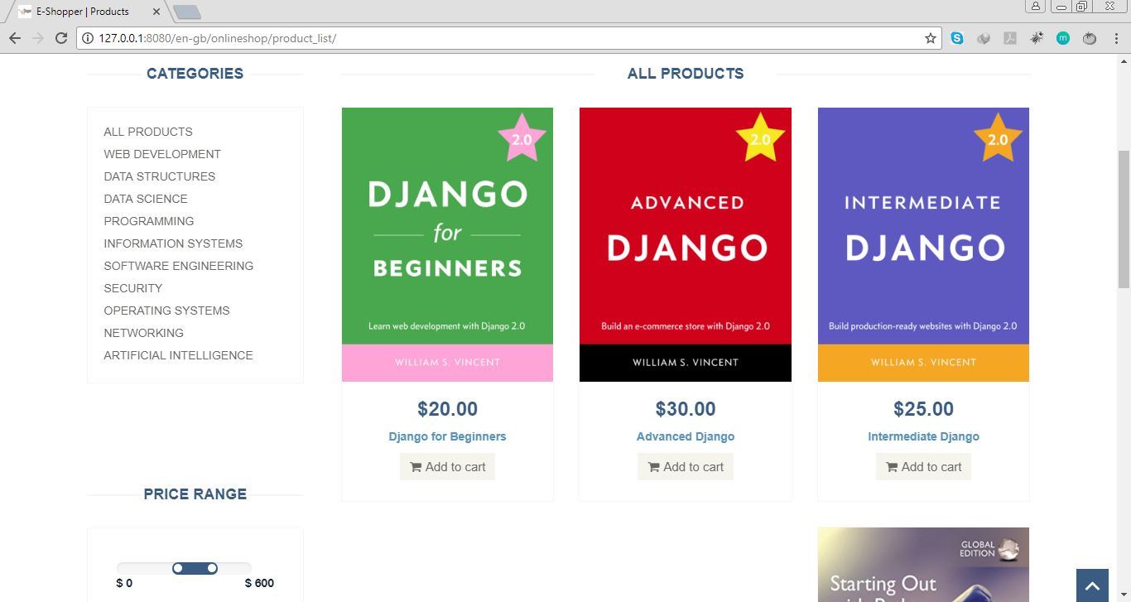

*Fig 5.8 Shop or Product list page*



*Fig 5.9 Product Detail Page*

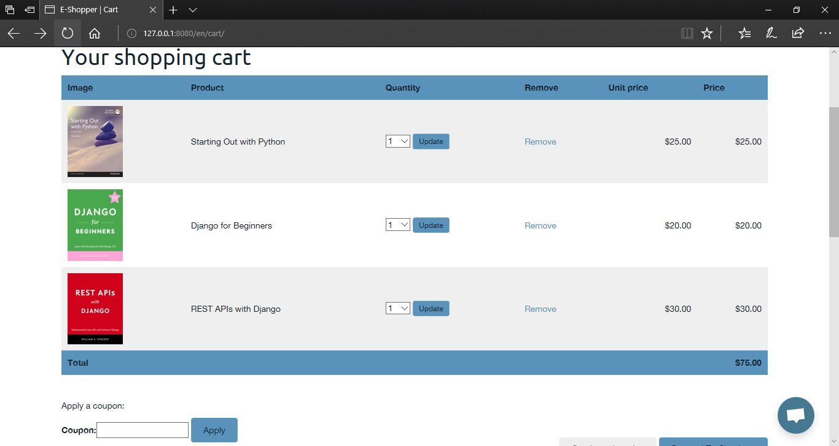

*Fig 5.10 Cart Page*

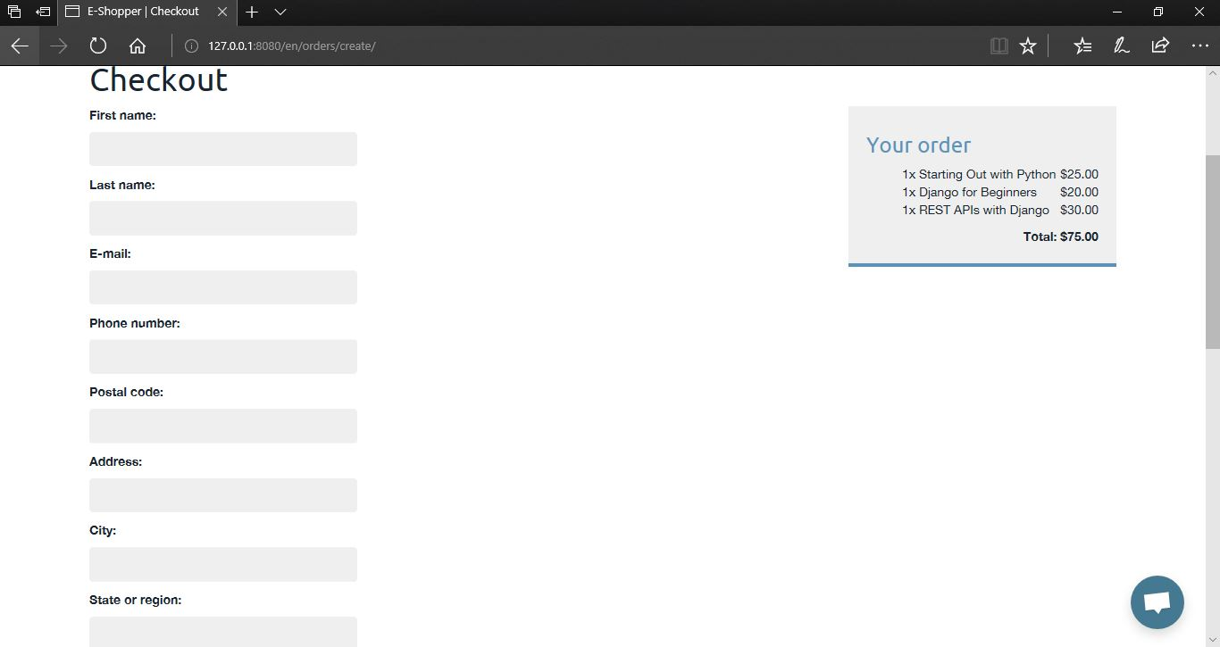

*Fig 5.11 Checkout Page with cart.*

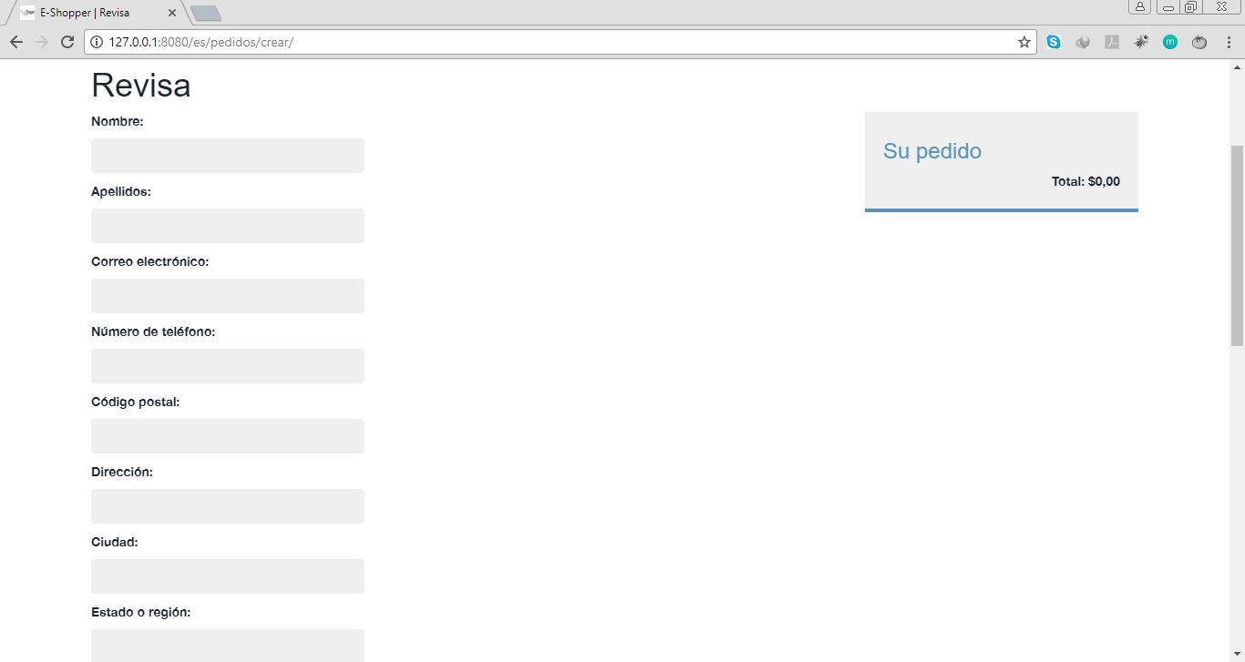

*Fig 5.12 Checkout Page with empty cart in Spanish.*

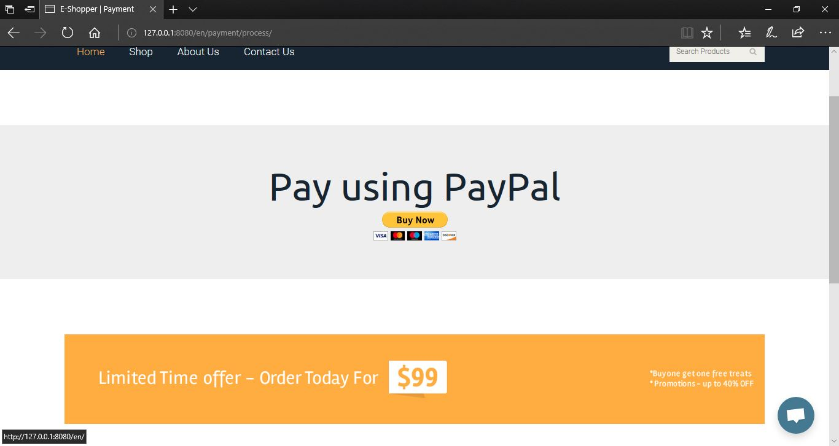

*Fig 5.13 Proceed to Payment Page*

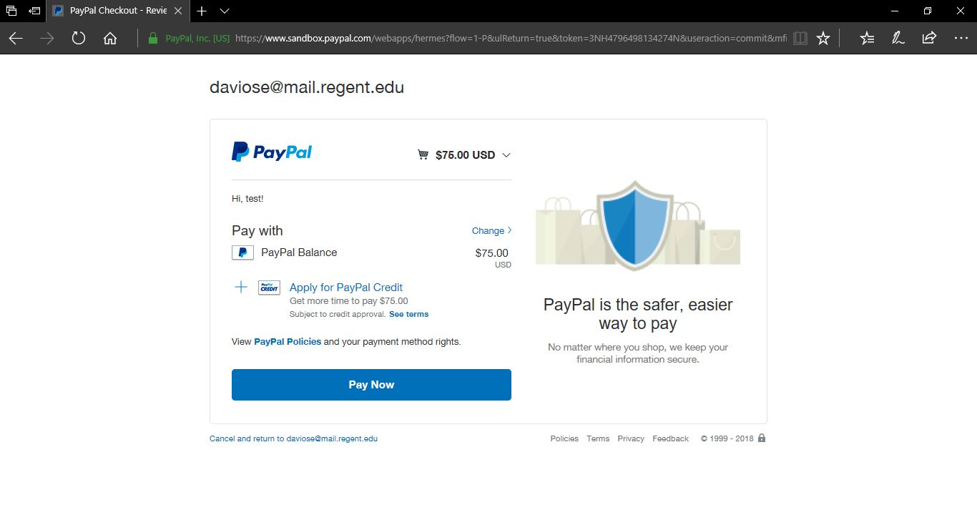

*Fig 5.14 PayPal Payment page*

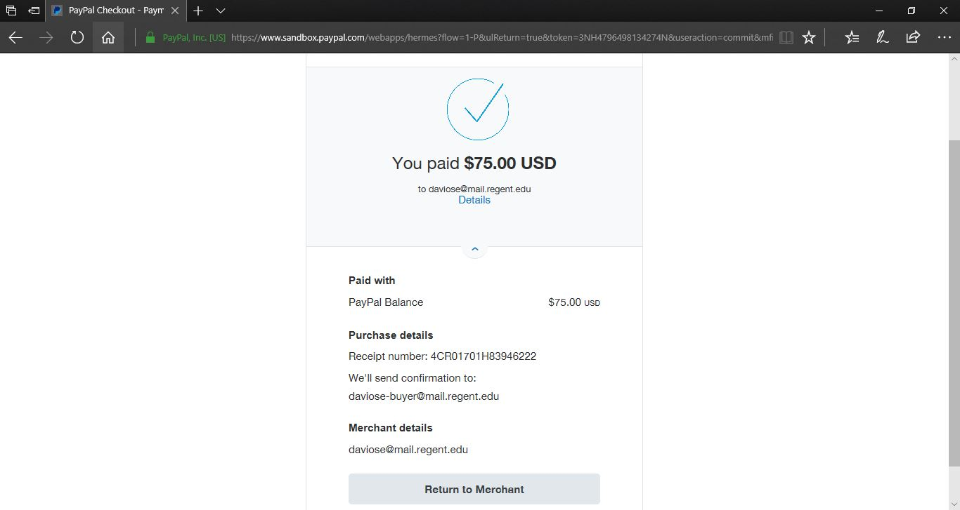

*Fig 5.15 PayPal Successful Payment page*

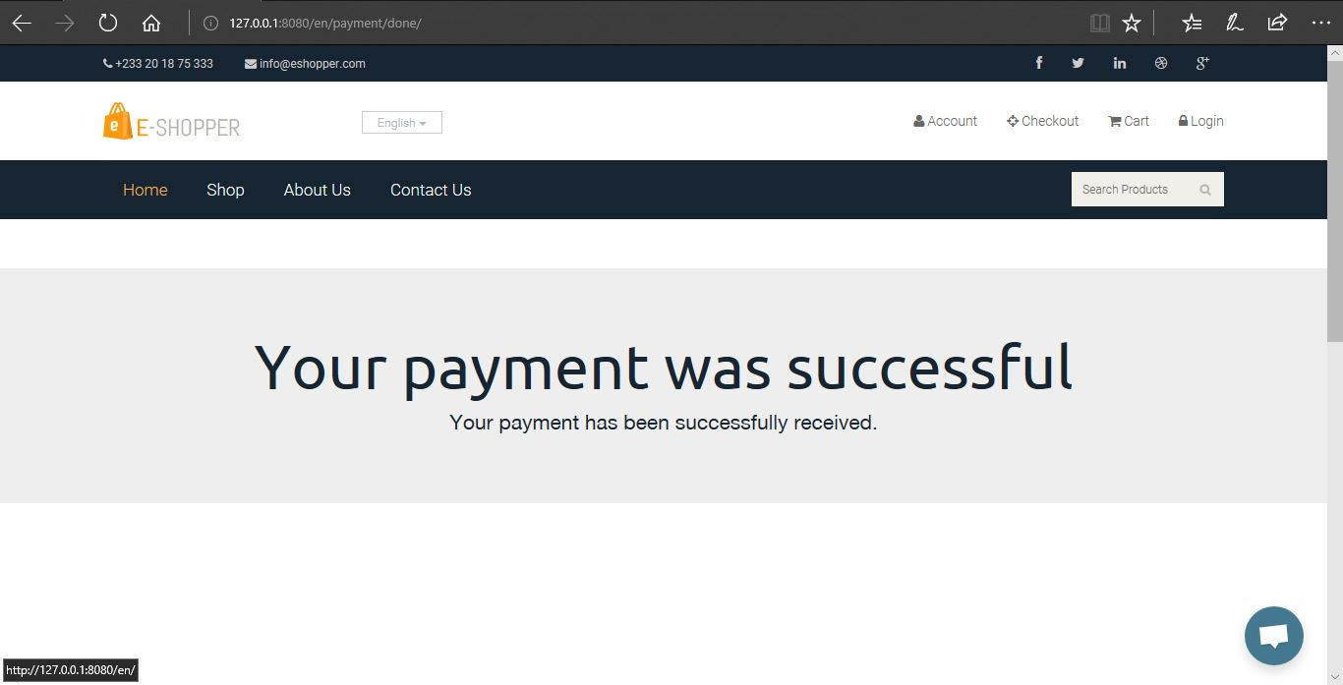

*Fig 5.16 Successful Payment Page*

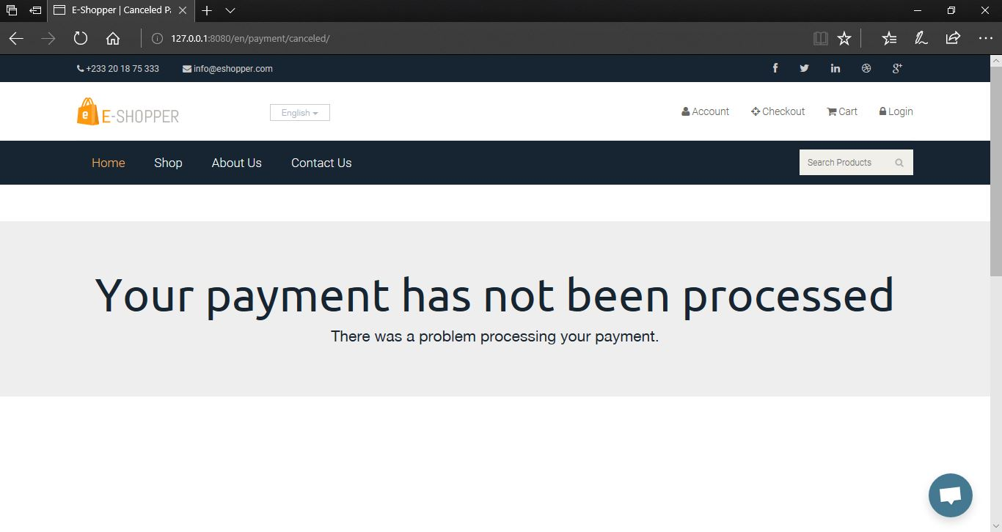

*Fig 5.17 Canceled or Unsuccessful Payment Page.*

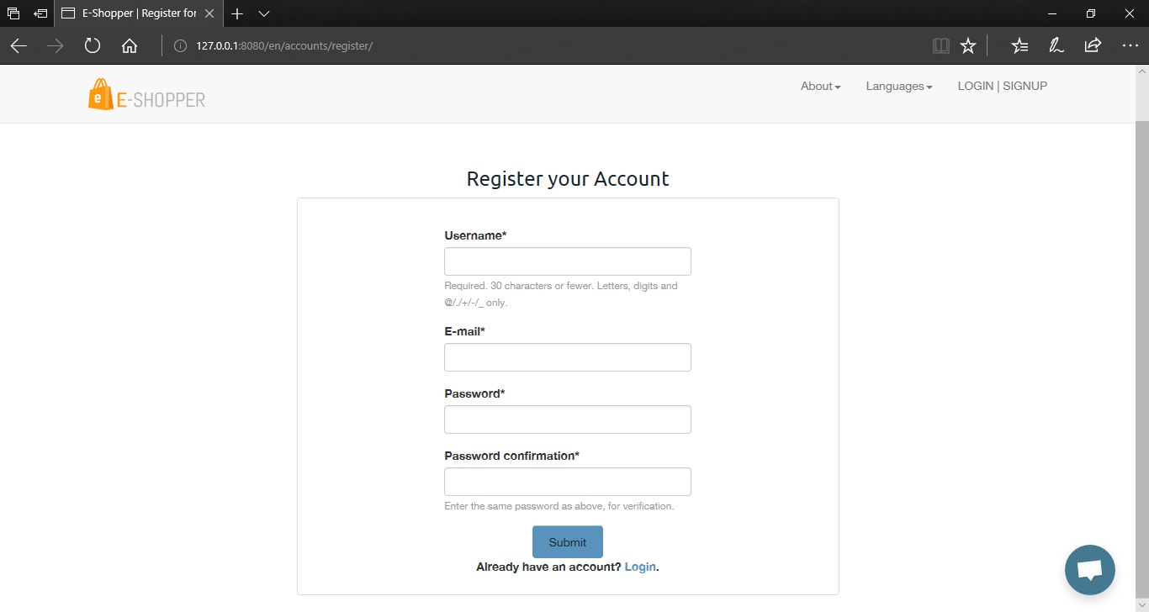

*Fig 5.18 Customer Register Account Pag*

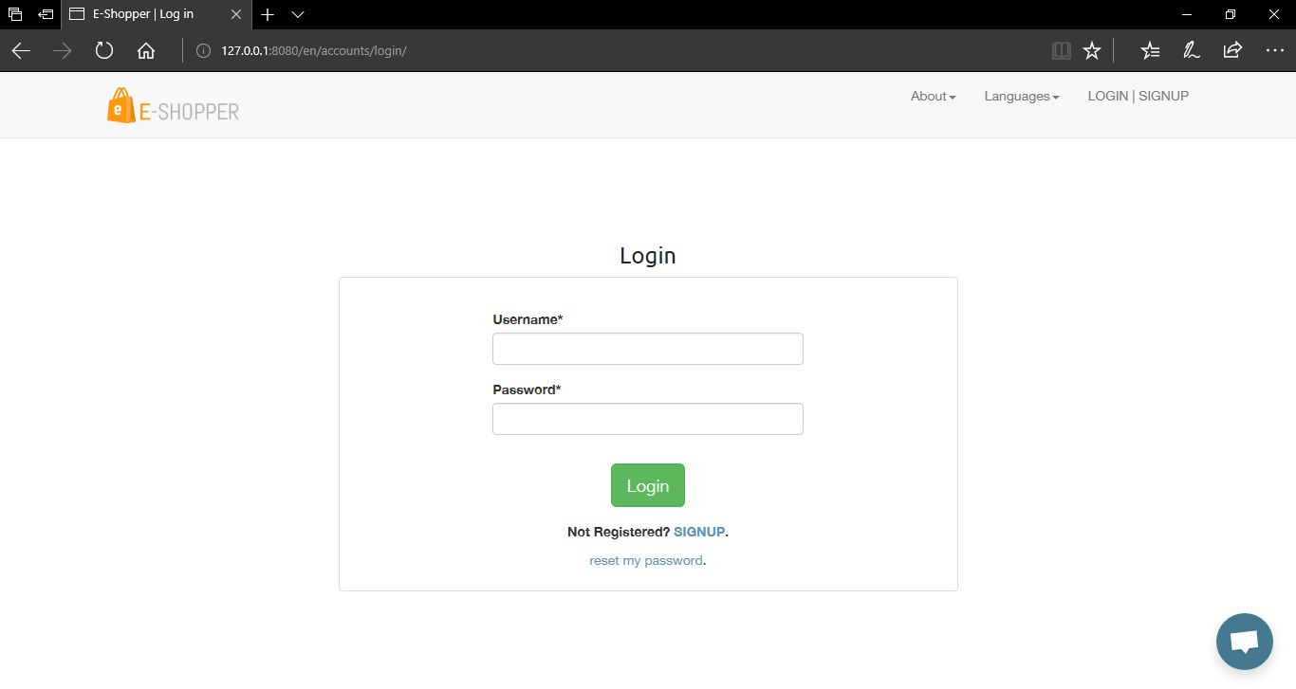

*Fig 5.19 Customer Login Page*

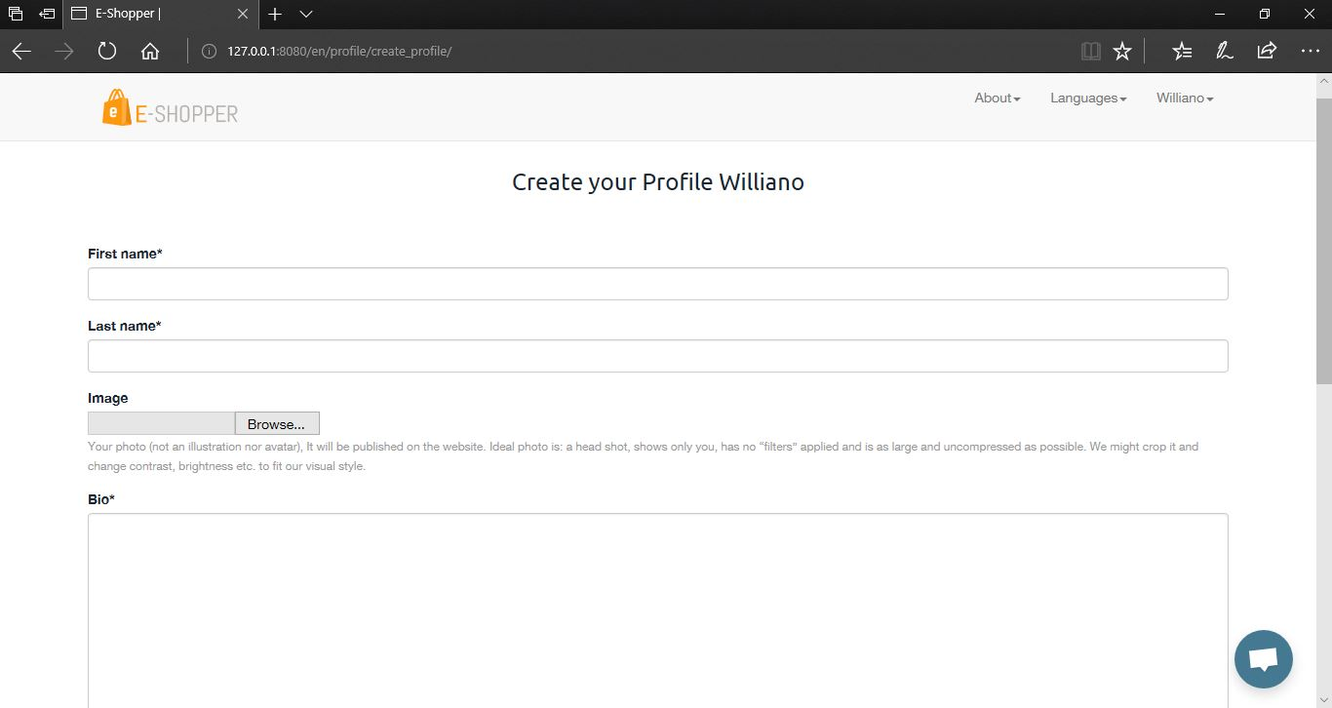

*Fig 5.20 Customer Create Profile Page*

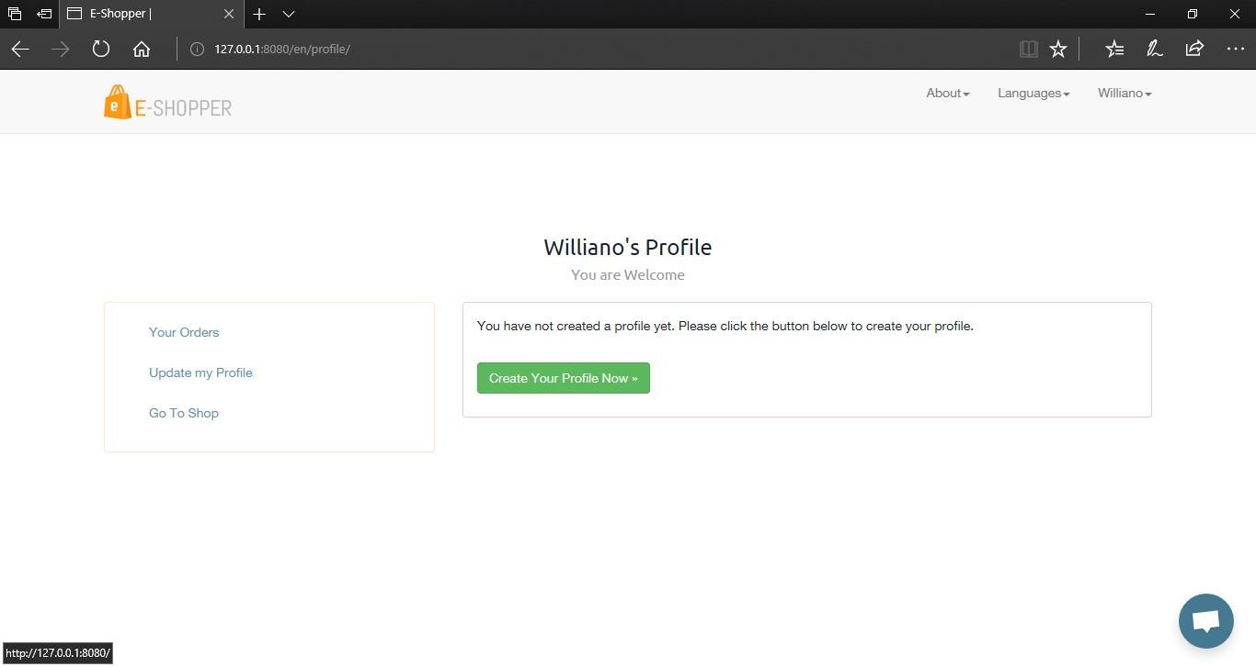

*Fig 5.21 Customer Profile Dashboard*

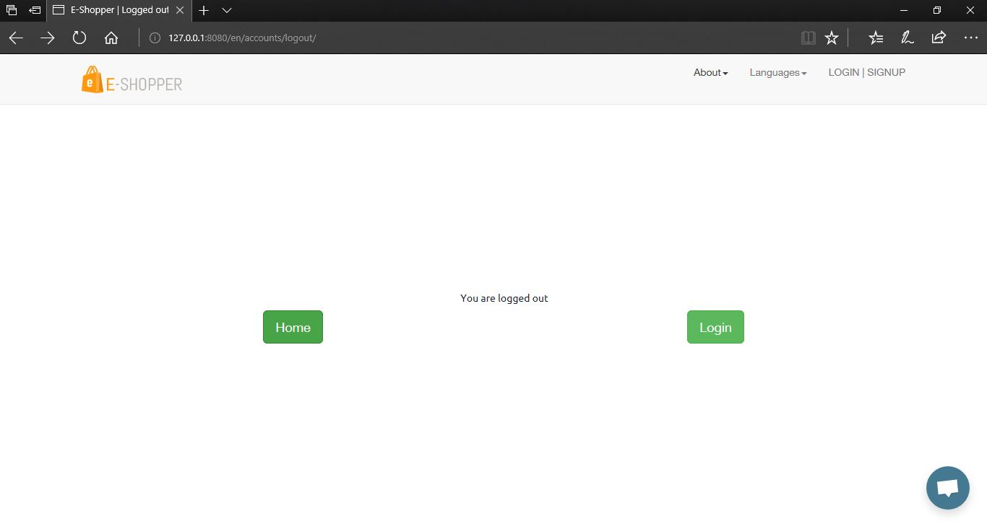

*Fig 5.22 Customer Logout Page*

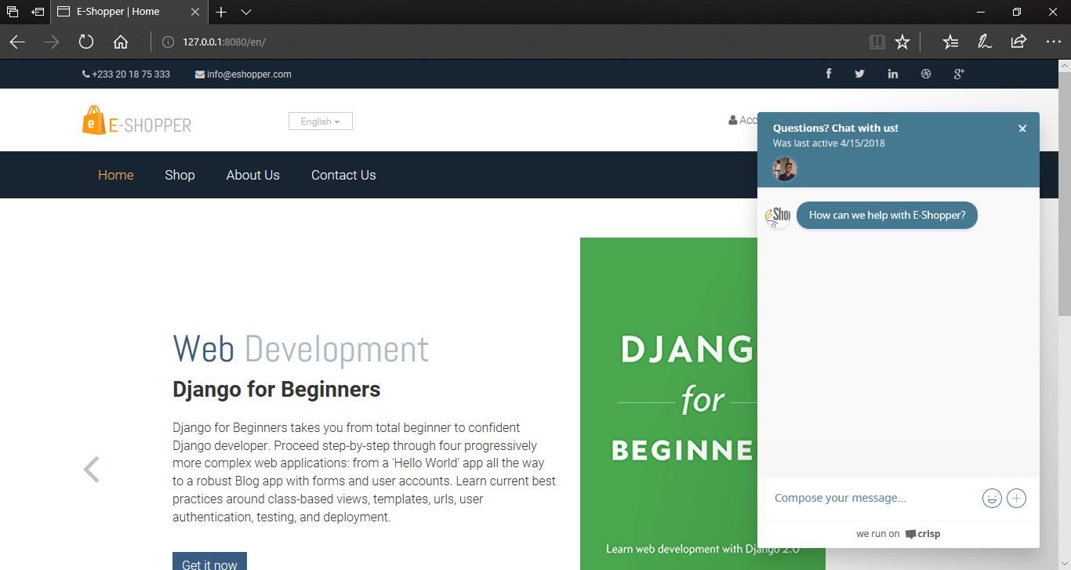

*Fig 5.23 Live Chat Support*

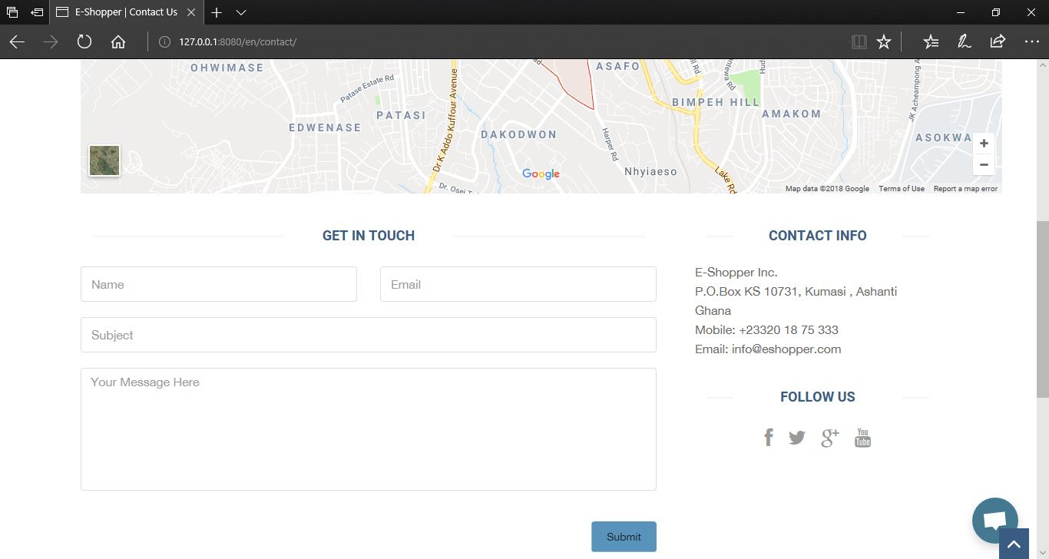

*Fig 5.24 Contact Us Page*

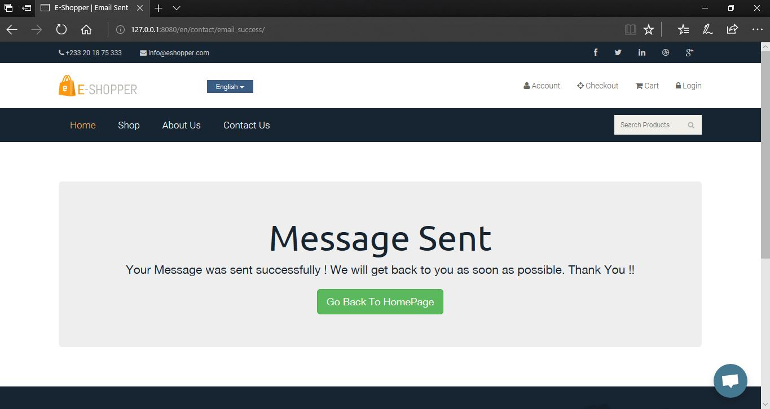

*Fig 5.25 Successful Contact Us Message sent page*

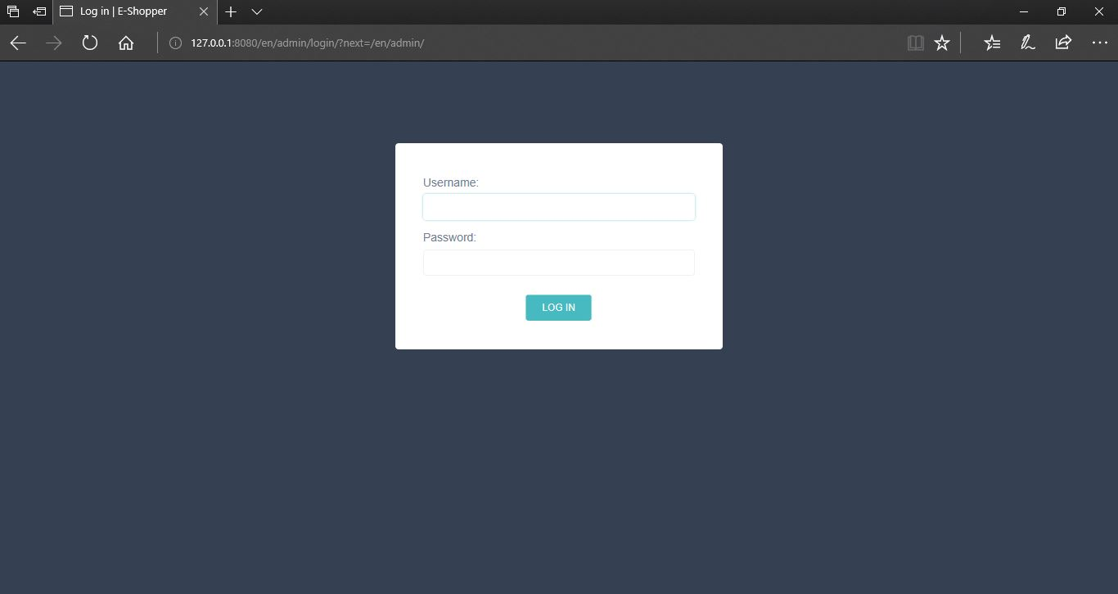

*Fig 5.26 Shop Owner or Manager Login Page*

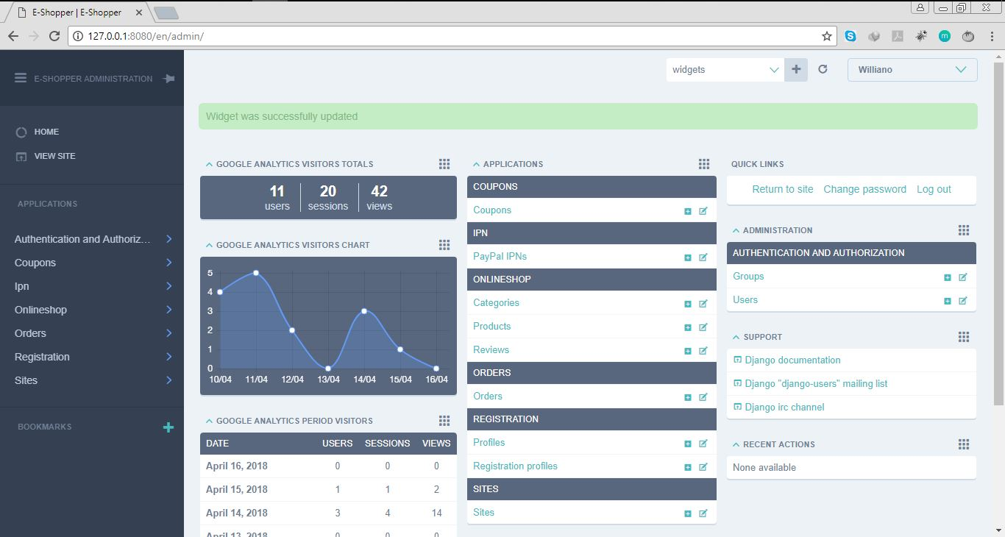

*Fig 5.27 Shop Manager or Owner Dashboard to accept orders, add products, add categories, add coupons with Analysis of people visiting the website*

**5.3 TESTING**

After the system developed, process of system testing must be carry on in order to test if the system is free of bugs. If during the system testing, there are bugs or errors detected, the developer may need to correct and fix the bugs immediately.

Testing is the process of evaluating a software or system to detect differences between given input and expected output. Testing is conducted to assess the quality of a system hence can be said to be a validation and verification process. This ensures that system meets the technical requirements that guided its design and development, works as expected and can be implemented with the same characteristics.

There are few types of system testing that must be performed which include the unit testing, integration testing, system testing, and acceptance testing. System testing is not a testing that is limited only to the development team but it also requires the help from specific outsider (beta-tester) to test on the system acceptance.

**5.3.1 UNIT TESTING**

Unit testing is a testing which requires the developer to test on every single part or component in the system. It is the practice of testing certain functions and areas known as units of a source code. This is important because it helps to verify whether the various units are functioning as expected, hence are returning the proper values, therefore it helps in identifying failures or errors in a source code. Every single step of unit testing will be recorded to the test plan for later testing review purposes. In the unit testing, the testing only involves members from the development team which mean beta-tester is not required.

With this system, various units were tested such as the product order unit, customer registration unit, payment unit among others to ensure they were returning the expected values. This system has two main units; one for the customer and one for the shop owner (manager). The two were tested to ensure that they functioned independently without errors in either of the two units affecting each other. This is relevant because it also helps in ensuring that the various units were error free and working in the most efficient manner.

**5.3.2 INTEGRATION TESTING**

Integration testing is a testing that must be conduct in order to test the integration between multiple pages of the system. After the unit testing, the entire units are integrated to form a complete system. The purpose of the integration testing is to make sure that there are no defects during the integration of multiple pages or modules. This is to detect inconsistencies between the various units after which system testing is performed on the system as a whole.

It is usually conducted after the unit testing. During the unit testing, the tester might not find any of the errors but it does not mean that the system will totally free of bugs since the system might not properly integrated which causes errors.

**5.3.3 SYSTEM TESTING**

System testing is a testing that must be conduct in order to test the complete system as a whole. The purpose of system testing is to test the whole application after it is considered completed. System testing is a very important testing since it requires the system to meets the requirements and quality set by the users.

This testing is conducted to evaluate the systems compliance with its specified requirements that is both functional and non- functional requirements.

In conducting system testing, some invalid input was entered into the system such as negative order quantity to ensure the system does not accept such values. This was successful because the system responded by alerting that the input was invalid. Also, the same was done with the date on which the order is to be delivered by entering dates that are past the default date. The system also alerted that the date was invalid. This enforced the fact that the system is validated and will not accept invalid input.

Also, the system’s payment process was tested to ensure that an order is only successful when payment is successful. This also was successful; hence the system performs in harmony with the functional requirements.

With the non-functional requirements, the system is very interactive in that it gives feedback to the user for every required function. The system is also easy to use since it has an easy and friendly looking interface. The system was also tested on other platforms apart from the laptop such as a mobile phone and a tablet, and the system fit onto those devices and functioned well. This proved that the system is also scalable as required.

**5.3.4 ACCEPTANCE TESTING**

Acceptance testing which will involve the outsider (my supervisor) to test the system in order to find out if the system meets their requirements from all perspectives. Acceptance testing is usually the final testing conducted to ensure the system to be delivered meets the specifications and purpose.

Once the system successfully goes through all the testing, the system will more likely to be delivered to the real world for use.

**5.3.3 RESULTS OF TESTING**

Below are some screenshots from the various testing we carried out to ensure that the system was functioning in line with the requirements analysis we gathered from users.

As stated above, during the system testing, the application did not accept negative inputs.

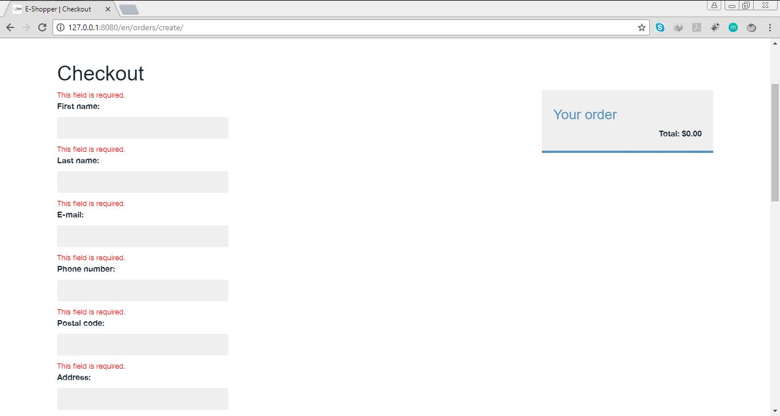

*Fig 5.28 Testing for a Customer checkout details.*

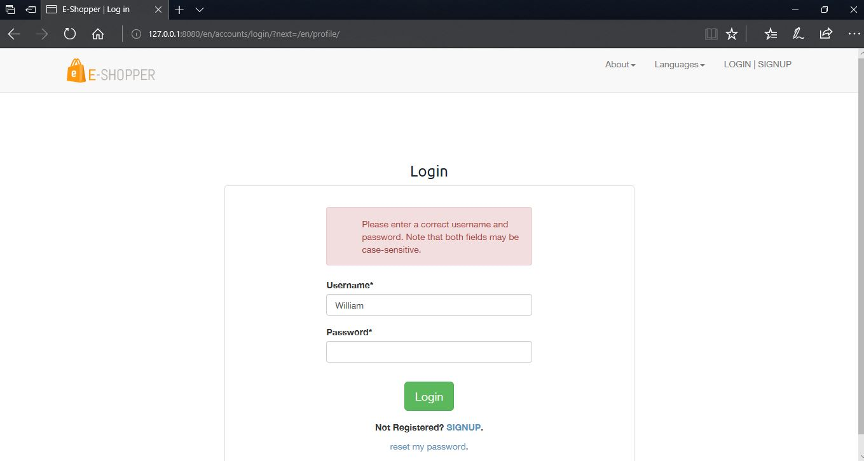

*Fig 5.29 Testing for a Customer login details.*

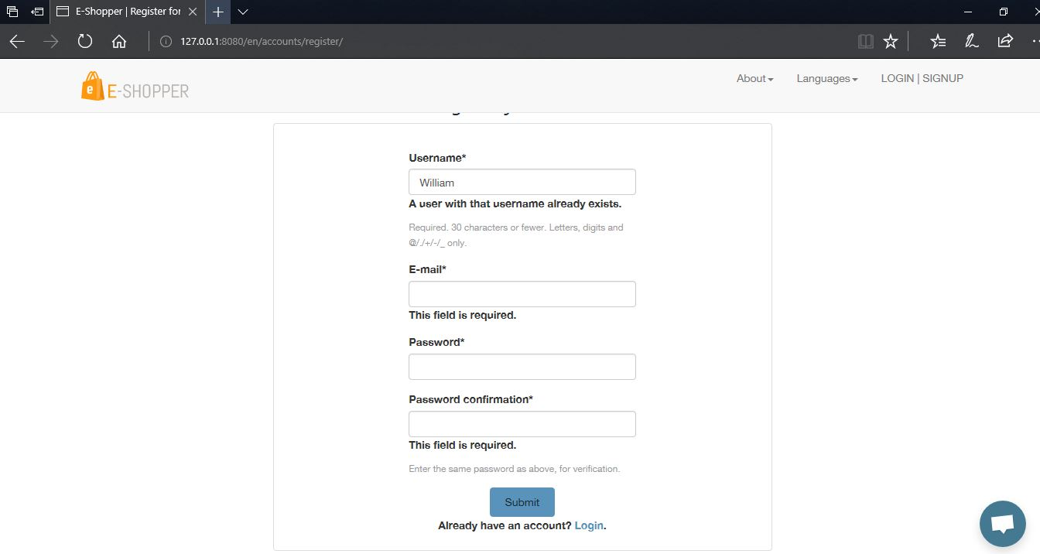

*Fig 5.30 Testing for a Customer Register details.*

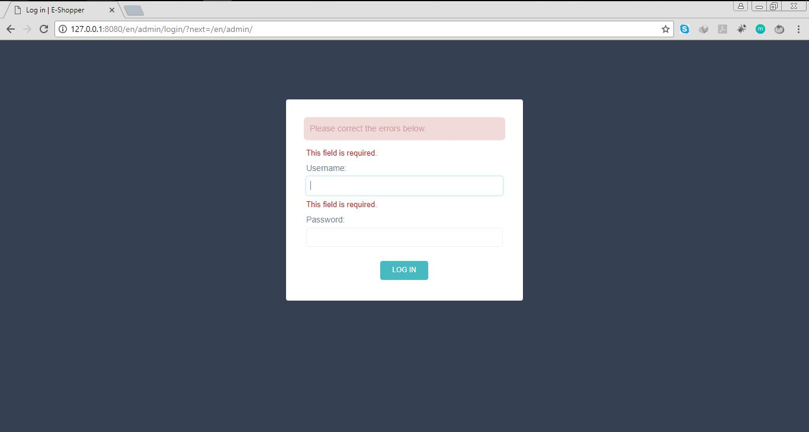

*Fig 5.31 Testing to ensure that the admin enters the right login in details.*

**5.4 EVALUATION OF THE PROJECT**

The purpose of evaluation is to assess the system as to whether it does what it is expected to do and if it is working properly. From the testing phase, the system was analyzed to ensure is functioning well according to the specified requirements.

One of the aims for designing and developing the online shop included easing customers of the stress they go through when shopping online. This system provides the solution to that, in that customers in their comfort can choose the language of their choice and place their orders. They also receive email confirming their order has been received and being processed which is very assuring.

The system is said to have an interactive interface which is also easy to use because the various products available are displayed on the shop or product listing page for customers to view and select their choice. The various products (books) have also been sorted into categories such as Web development, Software Engineering, Programming, Data Structures for easy searching and selection. Customers can therefore use the system as first timers without difficulties. These therefore will increase customer satisfaction as perceived in chapter one of this documentation.

Also, a payment system was implement as stated in the project scope. Customers can therefore only have a successful product order after payment has been done.

On the side of shop owners or managers, they can perform some managerial duties with the system such as edit products by adding books available or deleting books unavailable. With Google Analytics added, they can also see the number of people visiting their website. They can also reply to feedbacks from customers by sending them a direct email. They can generate reports in the form of PDF or Excel of the various orders received. This will help them access their performance over a specified period of time.

From the above, a conclusion can be made that from the evaluation of our project, the project meets its overall aim as stated in chapter one which is to design and implement a multi-lingual e-commerce system to enable online shoppers order products.

**5.4.1 EVALUATION OF SOLUTION**

Testing and evaluating the system has helped to realized that the system serves as a solution to the problem statement in chapter one. All that customers have to do is choose the language of their choice and make their orders without any language barrier. The problem of e-commerce having poor records is also solved. This is because managers can use the application to access reports and status of orders and can also download them in PDF or Excel format for record keeping.

From the above, a conclusion can be made that the system is a solution to the problem aimed to address and solve.

**5.4.2 EVALUATION OF METHODOLOGY**

The agile method with the incremental software process model was adopted to develop the application as stated in chapter three. This approach best suits E-commerce website development because the application was developed in increments and based on the suggestions of my supervisor, the necessary changes were made until the final phase was reached. This made the development much easier and helped to meet the various user and system requirements.

**5.5 CONCLUSION**

In this chapter, mapping the logical design onto the physical platform was looked at where the logical database schema was transformed into executable codes. A look at constructions where we the various user interfaces displayed were discussed in the previous chapter. Screen shots of the various forms, reports, etc. were captured under construction. Testing of the whole system was examined. Both unit, integration, system and acceptance testing were performed to ensure the software was working as required. Finally, evaluation of the project where highlights of the various efforts put in place to make this project a success was looked at.